

PROJECT REPORT OF INT213

On

**MUSIC PLAYER**

Submitted by

|  |  |  |  |
| --- | --- | --- | --- |
| Sl No. | Name | Regn No. | Roll No. |
| 1. | Gourav Patel | 11905228 | 54 |
| 2. | Anurag Kumar | 11905021 | 25 |
| 3. | Niraj Kumar | 11905067 | 27 |

Under the Guidance of

**SAGAR PANDE**

**School of Computer Science & Engineering**

**Lovely Professional University, Phagwara**

**Abstract:**

In order to solve the problem of complex functions and large required memory of PC music player on the current market, a new music player of simple, convenient, less required memory as well as user-friendly is developed using **PYTHON (3.6.1)** lead to design and coding of music player. The new design mainly realizes six core functions including main play interface, playlists, menus, volume control, file browsing and song search. This player has merits of high performance, simple operation, and run independently on the Personal Computer. At the same time, the player can also browse and access files in PC files.

1. **INTRODUCTION**

This chapter gives an overview about the aim, objectives, background and

operation environment of the system.

* 1. **PROJECT AIMS AND OBJECTIVES**

The project aims and objectives that will be achieved after completion of this project are

discussed in this subchapter. The aims and objectives are as follows:

* Offline Music player
* Open Source, very simple interface
* Support of most important sound formats (MP3, WMA, AAC)
* Can modify the volume via player volume.
  1. **BACKGROUND OF PROJECT**

It provides a player object which represents the player. It needs a generator player queue which yields Song objects which provide a way to read file data and seek in the file. The main usage is probably in the Music Player project – a full featured high-quality music player. The purpose of making this application is to develop a player which can play the mainstream music file format. To browse and query the storage space as well as operation of adding, deleting, and playing can be realized. Meanwhile, this software can play, pause and select songs with latest Button and next Button according to users’ requirement as well as set up songs’ order.

**The required software of the developing environment**

|  |  |
| --- | --- |
| **PROCESSOR** | **INTEL CORE PROCESSOR OR BETTER**  **PERFORMANCE** |
| **OPERATING SYSTEM** | **WINDOWS VISTA,**  **LINUX, WINDOWS7** |
| **MEMORY** | **1GB RAM OR MORE** |
| **HARD DISK SPACE** | **MINIMUM 2GB OR ABOVE FOR**  **STORING SONG** |
| **PLATFORM USED** | **PYTHON [3.6.1]** |

**2.SYSTEM ANALYSIS**

In this chapter, design steps and the results of functional modules in the system are given in details.

**2.1 Introduction of player project.**

In this section, the App Starting module of the player in the project is introduced. Introduction of Application Starting module in the project any application Starting needs Manifest file to start. And any new project content will automatically generate an Manifest file. Configuration files are the core of the whole program, which contains the PC version, and the default Activity in program running. The systems will automatically looking for a logo in Manifest to react the corresponding operation when any component of the program triggers events. To define the system, the first thing is launching the .exe. Most of these are the default values of the system. Setting the action and category realize the switch between different Activities. When any components of the program is about to use, declaration must be in the Manifest files. To be clear that authorities must be illustrated as the statement of provider. Each component has a lot of attributes; the program will define different attributes according to different needs. Introduction of engineering program structure The basic structure content of PC project includes: the SRC (source code), gen (constant that windows automatically generates), res (resource file), and the layout of file and pictures in the main storage program interface.

Screenshot of python idle:-

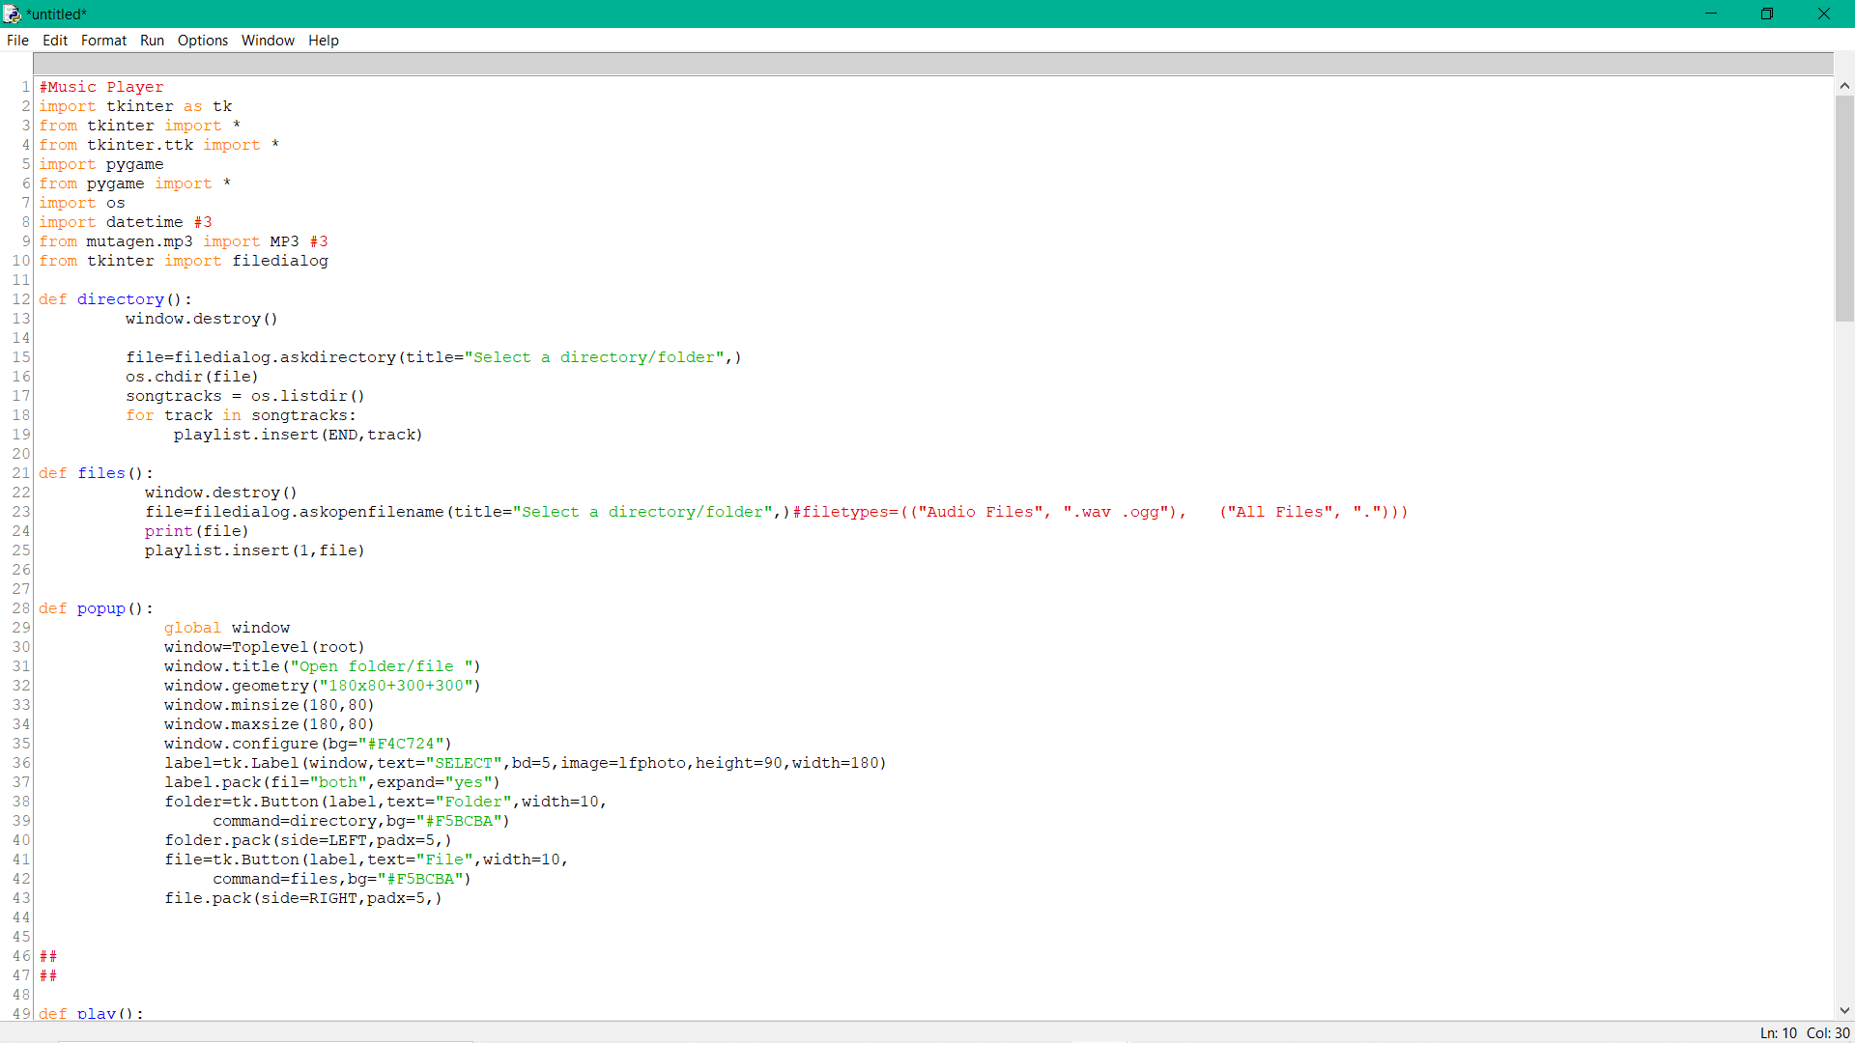

**2.2 Part of the function design: -** The main play interface design.

Convenience and practical should be fully considered in the design of the main interface.

* There are no corresponding songs for the first time login entering the program
* Users need to add songs to play. Therefore, you need to press the adding song or adding folder button.
* When need to use the player to play appropriate music, click the play button to realize the function.
* When need to use the player to switch to the previous song, click on “Move Previous music” button to realize the function.
* When need to use the player to play the next song, click on “the next music” button to realize the function.

**2.2.1 Playlist Design: -** A view called List view in PC, with the characteristic of Base Adapter attribute. This can display the form of top to bottom or left to right. Play menus six functions , including play, pause, resume, next, previous, add, volume, select song file or folder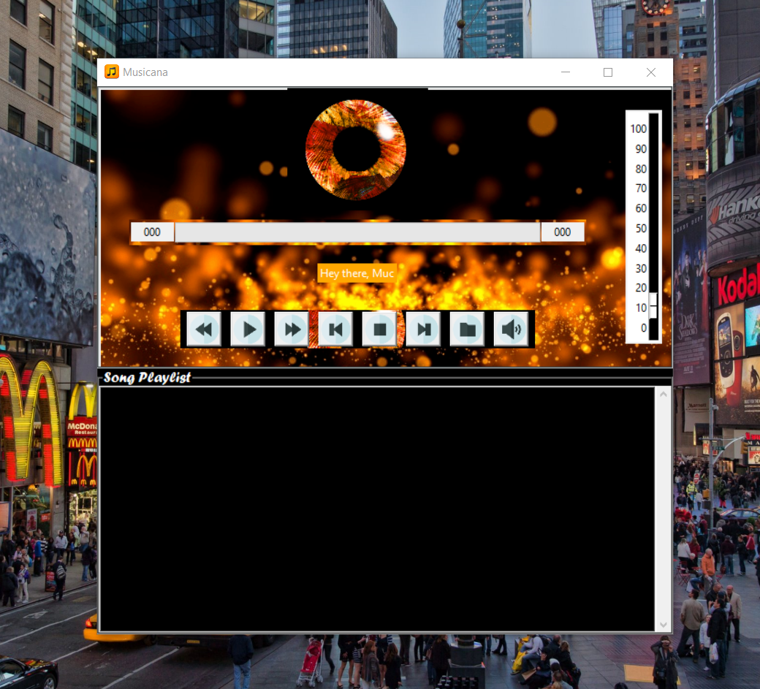

|  |  |
| --- | --- |
| **Play** | Enter the menus, input the songs name and realize play |
| **Add** | Enter the menus and songs in the playlist |
| **Pause** | By clicking this button song will be paused then there. |
| **Resume** | Resume the song from where it has been paused. |
| **Volume** | Users can control volume of any song by volume slider |
| **Stop** | Stops the currently Playing song. |
| **Mute** | Mutes the song |
| **Unmute** | Unmutes the song. |
| **Next** | Plays the next song. |
| **Previous** | Plays the previous song. |

**2.3 SYSTEM REQUIREMENTS**

**The principle of software design mainly includes the following points:**

1. **Reliability:** The reliability of the software design must be determined. The reliability of the software system refers to the ability to avoid fault occurred in the process of system running, as well as the ability to remedy troubles once the fault occurs.

2. **Reusability:** Look for commonness of similar codes, and come out new method abstractly and reasonably. Pay attention to the generic design.

**3. Understandability:** The understandability of software not only require clear and readable document, but the simplified structure of software itself, which requires the designer possess keen insight and creativity, and know well about the design objects.

4. **Simple program:** To keep the program simple and clear, good programmers can use simple program to solve complex problems.

5. **Testability:** It means that the created system has a proper data collection to conduct a comprehensive test of the entire system.

6. **The Open-Closed Principal**: Module is extensible but cannot be modified. That is to say, extension is open to the existing code in order to adapt to the new requirements. While modify is closed to the categories. Once the design is completed, the categories cannot be modified.

**Requirement Analysis of System**

**The feasibility analysis**: This section verified that it is feasible to add music player on the PC from the aspects of : -

* **Economic feasibility**
* **Technical feasibility**
* **Social feasibility**

**Data Storage: -** When players run normally, because of the switch among interface, in order to avoid the data lost , we need to store some data for temporary or permanent storage.

**Conclusions**

Through the development of music player on windows platform we get a clear understanding of overall process of the system. The core part of the music player is mainly composed of main interface, playlists, menus, play Settings, file browsing and song search. Grasping the development of the six parts, the music player has had the preliminary scale. Based on the function of the six categories, add some other small features. It has also some other features like VOLUME CONTROL and SHUFFLE song.

**SNAPSHOTS OF ADDING FEATURE**

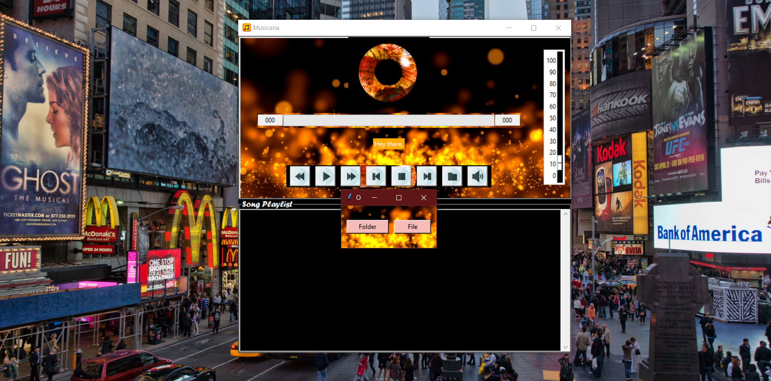

**SNAPSHOT OF PLAYING FEATURE**